Gromit
PRODUCT DEFINITION

Product Manager / New Product Planning: Graham Brooks

Table of Contents
Section A: Product Vision / program Targets 1
Section B: Product Requirements 6
Version History 12
Appendix A 14
Appendix B 16
Appendix C 17

The electronic version of this document resides in \\Shareserver\HEPD\Projects under the appropriate category and codename. If you would like to receive updates by email when new revisions are released, please send email to the New Product Planning contact listed above.

Section A: Product Vision / program Targets

1 Product Vision

Product Description
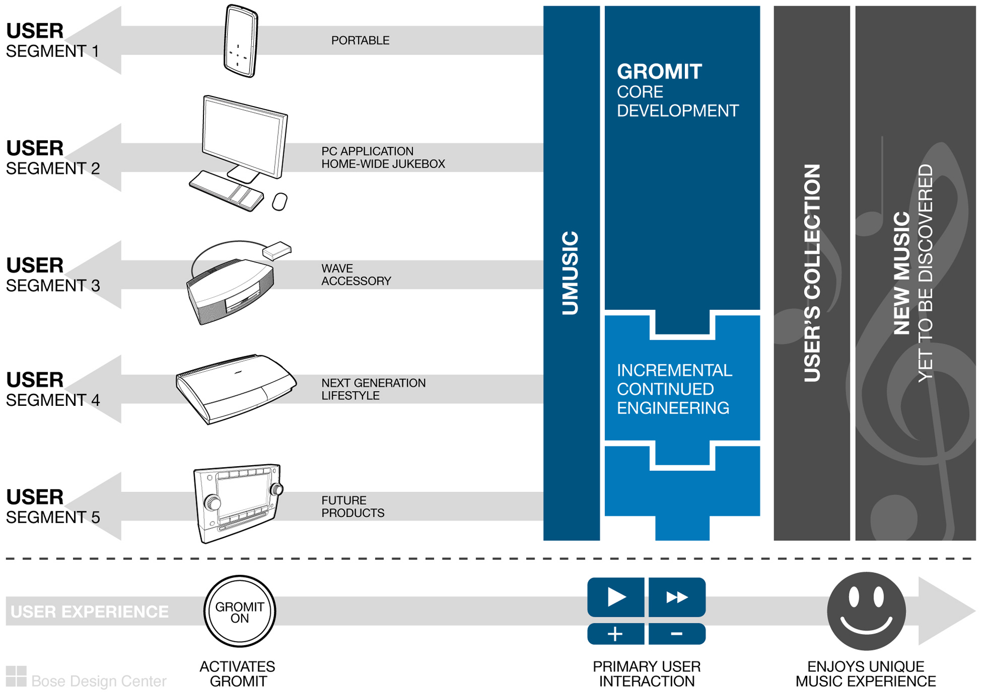
Gromit is an internet music subscription service and accompanying software that will be marketed as a personalized, no hassle, no time commitment music experience for today’s busy consumer. It uses the uMusic™ intelligent playback technology to automate next track selection and new music discovery. By extending the uMusic catalogue of potential tracks beyond the user’s collection to a catalogue of 1,000,000+ tracks, users are effortlessly exposed to music that they haven’t heard before but will likely enjoy, mixed with music from their collection. Also, Gromit enabled devices can provide the benefits of digital music with virtually no initial set-up time: no computer, no CD ripping, and no playlists needed.

Gromit will be offered exclusively on ‘Gromit Enabled’ Bose user interfaces (UIs). Through a centralized uMusic preference server, users can experience the same, unique music experience across various devices and throughout their lives. Gromit will be a single platform designed to be expanded as needed to satisfy the desired user experiences for the enabled devices including: a portable MP3 player, a PC based jukebox and home-wide distribution hardware, an enabling accessory for Wave, a next generation Lifestyle, and a car audio head unit. Future products could include: a car stereo adaptor for the portable player, music services enabled cell phone, and a music services enabled source-less solution.

Gromit will be built in stages to minimize risk, reduce development cost and shorten time to market. The first development stage will be the core services: metadata delivery, music subscription, and potentially inter-device preference exchange. Subsequent stages may include music identification services and client/server versions of uMusic, etc… and will be built as they become necessary to enable future devices. Most development as well as the music subscription and related billing systems will likely be outsourced.

We expect Gromit to include:
- Access to a large collection of music: at least 1,000,000+ tracks, likely to be 2,000,000+ tracks.
- The ability to invoice and receive payment from customers for their use of the subscription service.
- The ability to enable customers to update their personal/billing information.
- The necessary infrastructure updates to provide a high quality product and customer service.
- Metadata delivery and eventually music identification services (fingerprinting and/or TOC lookup).
- Eventually a centralized user preference database including information about a user’s collection.
- DMCA compliant music streams, on-demand access to music, and purchased track download.

Additionally, we do not expect Gromit to include:
  - Any customer facing hardware.

1.2 Internal Advertisement
Finding a desirable music experience is too much hassle for modern life. You used to enjoy music, when you had fewer responsibilities, back when you had time to choose the tracks you wanted to hear and find the albums. Nowadays, with your hectic schedule, the only time you have for music is listening to the radio while driving. But with radio, you can have interruptions from DJs and commercials, and even when they’re playing music, it’s not always the music you’d choose if you had the time to find the right CD.

We’ve invented a music experience for today’s hectic world. No hassle…no time commitment…just great music. Gromit learns your music preferences as you listen. Then, using an extensive database of information about each track, album, and artist, Gromit automatically creates an ideal music experience specifically for you. Gromit provides great music chosen just for you at the touch of a button with no hassle and minimal setup.

The music collection you’ve always wanted. The Gromit music experience is created from a collection of over 2,000,000 tracks from more than 200,000 albums from all western music genres spanning Beethoven to Eminem. Gromit expertly mixes music you’ve heard with music you’ve yet to discover to create an experience that evolves with you.

Look for ‘Gromit Enabled’. Only Bose, in partnership with Microsoft and MusicNet, has the breadth of product and depth of technical expertise to offer a personalized music experience throughout your life, simply at the touch of a button. All Gromit Enabled products share some common user-interface elements and are integrated to deliver the same uMusic-based listening experience regardless of device. Whether in your home, office, car, or on the go, Bose has a Gromit Enabled device for you. Begin enjoying music again with a brand you trust, Bose.
1.3 Business Need for Product
The business reasons for Gromit are threefold:
- Gromit is a substantial growth opportunity for Bose and could create a sustainable product franchise.
  - Bose can satisfy unmet needs for new and traditional customers with the Gromit experience.
  - There is significant revenue potential for both the Gromit service and enabled devices.
- There are Gromit enabled devices, which require Gromit, under pre-development and on the LRP.
- Gromit expands our uMusic and Homewide initiatives and provides a monthly connection to users.

Without Gromit, products including Satori, Hannah, Soak and Cortez will lose a key feature and may no longer have sufficiently compelling value propositions or enough differentiation to be viable. However, in conjunction with Gromit, these devices are a strategic growth opportunity with large revenue potential.

Gromit, initially as a differentiating feature, and later as a brand, has the potential to drive the creation of a new Bose franchise that can command a sustainable price premium in a growing market. The franchise will be based around the Gromit music experience and will facilitate cross-selling through a monthly billing relationship with the customer. It will ride the recent trend towards mass adoption of digital music. As a brand trusted to provide simple, elegant, high performance systems, Bose is uniquely positioned to help the less tech savvy or hyper-busy (baby boomer) customer make the transition to digital music.

Gromit extends our investment in uMusic and though Homewide and ASD, enables a unique music experience throughout a consumer’s life. The monthly billing provides an ongoing connection with users.

The Gromit customer may be different than the traditional Bose customer. Specifically this customer:
- Wants to enjoy music throughout their life with no hassle and no time commitment.
- Is time constrained and perceives setting up an acceptable music experience using CDs as too much hassle. Probably primarily listens to music in the background or on shuffle.
- Is interested in variety, not settling for hearing the same album over and over again.
- Eventually, after launch, this target customer may already have a Gromit enabled device, love the unique music experience and be looking to access it in other music listening environments.

1.4 Unique and Sustainable Advantages
Bose will establish the Gromit brand and create a franchise capable of demanding a market premium by:
- Launching the Most Compelling Music Service and Portable Solution on the Market: Bose and partners have the expertise to solve the difficult problem of integrating a subscription service and a portable device to create an easy, enjoyable music experience. Industry discussions have affirmed the uniqueness of our vision for a simple music subscription service. We will be first to market with products embodying this vision and our uMusic technology. We will provide a simple user-interface and user-interaction that enables a rich musical experience from a large catalogue of music. The simplicity of our solution will be a high hurdle for competition to overcome.
- Leverage a Unique Combination of Bose Capabilities to Delay Competitors: Substantial audio engineering expertise and products already available in most music listening environments, uniquely position Bose to create the ecosystem necessary to provide a common Gromit experience throughout a customer’s life. Also, our direct channels and direct marketing expertise will enable us to explain the advantages of digital music subscription and the unique value of Gromit to our customers. These capabilities will delay competitors from copying Gromit long enough for us to build a critical mass of advocates and establish the Gromit brand as the premium musical experience.

Bose will sustain and protect the Gromit franchise into the future from competition and knock-off through:
- Switching Costs: Once established, uMusic preferences are a sunk cost and deter switching.
- The Gromit Brand: The Gromit brand will represent the richest, hassle-free music experience.
- Continuing Technical Leadership: Bose will maintain this leadership position and the premium Gromit brand by continuing to create the most compelling user experience through ongoing hardware and software research and development. Each enabled product will continue to be the best offering in its category with unique sustainable advantages. Also, the Gromit subscription service will continue to evolve ensuring that it remains the easiest to use and most compelling.
1.5 Objective Evaluation or Controversial Points
- Gromit’s development and management costs will be huge, how can we generate the target ROI?
The Gromit service and the Gromit-enabled devices are projected to generate substantial annual revenue (~$1B) for HED. At this scale and as a service business, the traditional financial model doesn’t accurately reflect the profitability of the Gromit business. We believe Gromit will be profitable because:
- When representing the music service vendor as the sales channel, the Gromit business shows a high IRR (>50%) in the traditional business model. This structure also better reflects the transactional reality because they bill the customer and compensate the music labels.
- The Gromit business has a good R&D profitability gain (>9x) and very high revenue gain (>40x).
- Gromit also offers additional, indirect financial gain by creating new and continuous communication channels with the customer: we have access to both the OSD and the monthly bill where we can target value add advertising and loyalty building programs such as concert schedule and favorite artist info.

- Bose has not successfully launched or managed an online service, why will Gromit be successful?
Most of the Gromit development and operation will be outsourced; however, it will likely require some additional infrastructure and some organizational changes. With this in mind, Gromit is assembling a cross-functional team including: Research, Product Marketing, IS, all Sales channels, PTS and Finance to lead implementation of the necessary infrastructure and champion the organizational changes.

- Do customers want subscription services or just pay per download? Can we sell subscription services to customers that may not understand it? Will we be able to effectively message Gromit?
The popularity of pay per download today is driven by the success of iPod, which is credited to their vertical integration enabling them to provide a seamless experience from service to device. It is our belief and general belief in the industry that once a vertically integrated and compelling subscription service and device solution such as Gromit is available, adoption rates will rise dramatically. Gromit also has a simple message – no hassle personalized music experience – that can be tailored to convey the benefits to each devices respective target customer. The message does not focus on enabling technology or mechanics, for example, Soak (Gromit enabling accessory for Wave) can be described as “personalized radio.”

- Will Gromit provide a DMCA compliant service tier and if so what are the legal risk?
Gromit will supply both a DMCA-compliant radio service tier and an On-Demand service tier to be used singly or together as dictated by the individual enabled device product visions. Todd Krieger working with outside council and DMCA experts from several potential partners has defined low risk guidelines for which device visions can be implemented with a DMCA compliant audio stream.

1.6 Distribution Approach
 | The goal is to enable Gromit in all geographies. However, at launch, we will likely be restricted to US, Canada and some countries in Europe (UK and maybe France, Germany) by the anticipated limited reach of our music service vendor. Gromit expects to expand into key Asian and APAC countries such as Japan, Korea and Australia by 2009.
  Geographic Distribution
  US
  Europe
  Japan
  Asia/Pacific
  AIM

Distribution Channels |  | Distribution will be decided by the individual Gromit enabled devices. However, we recommend that at least initially all enabled devices exclusively distribute through direct channels to facilitate honing of the customer message and capturing necessary information to initiate the subscription services.
Wholesale
RDG
DMG
CFDT
OCG
Other (describe)

2 Program Targets

2.1 Business Assumptions
Business Parameters | Assumption | Explanation / Justification
Year 1 Unit Volume | 1,000,000 | Projected sales volume is dependant on enabled device sales. We are expecting an attach rate of 80% - 99% for products dependant on Gromit for core functionality, and an attachment of 60% for products in which Gromit is a key feature.
Year 2 Unit Volume | 2,000,000
Year 3 Unit volume | 4,000,000
Selling Price | On-Demand: $14.99 per month  DMCA: $9.99 per month | The On-Demand service tier is priced at the minimum it can be while maintaining the maximum profit potential for Bose given the anticipated revenue split with our music service provider. The DMCA tier is priced to maximize profit in the Accessories market, which is perceived to have a low elasticity, while still remaining below the standard pricing for the premium On-Demand service tier ($12.95 - $14.99).
Program Parameters | Assumption | Explanation / Justification
Revenue per Unit | On-Demand: $1.99 per month  DMCA: $6.99 per month | Based on music service vendor prices, $1/user/month projected Bose service operation costs and an average expected consumption of 1,400 DMCA songs/user/month.
Monthly Churn | 1.5% | Churn is assumed to be in the middle of comparables: Tivo 1%, XM 1.5%, and Cable 2%
Cost | On-Demand: $13, DMCA $4 | Based on initial quotes provided by MusicNet.
Development Cost | $10M | Based on estimates from the Program Management office.
Desired SOP date | 8/07 | Dependant on the anticipated SOP for the first Gromit enabled device.

2.2 Program Priorities
Program Parameter | Boundary Condition | Rationale for Boundary Condition | Importance Rank (1-6) | Rationale for Importance Rank
Product Vision (shalls) | Meets all “shall” requirements | The “shall” req’s, taken together, are the essence of product vision, and therefore are of critical importance. | 1 | If a “shall” requirement cannot be met, then the concept needs to be re-evaluated.
Platformability | Similar functionality is accomplished leveraging the same code base. | Strict adherence to platform development will ensure a consistent user experience and minimize development expense. | 2 | User experience will suffer and development cost will be prohibitive unless core features can be leveraged across enabled products.
SOP date | Needed by launch of 1st Enabled device | Enabled devices will not meet their product visions without Gromit. | 3 | Gromit is the gating development effort for launch of several devices.
Standard Cost | $15: On-Demand tier  $10: DMCA tier | Gromit will not support its operations if standard cost exceeds price. | 5 | IRR is sensitive to standard cost.
Development Cost | TBD (predevelopment) | Task for pre-development because we don’t have a financial model yet. | 4 | IRR is less sensitive to development cost.
Product Vision (shoulds) | Meets all “should” requirements | The “should” req’s, taken together with the “shall” req’s provide the most compelling user experience. | 6 | N/A

Section B: Product Requirements
Definitions of Requirements
Shall: Mandatory. If requirement is not met, program is out-of-bounds and may be cancelled.
Should: Target. If requirement is not met, team must justify decision at approval meetings.
Nice To: Guidance. Team is requested to implement this requirement at their discretion.
No Need To: Non-requirement. Business has no need for this feature or behavior.

 | Requirements |  | Implementation Notes

1 Product Fundamentals
B.1.1 | Gromit is a platform that provides back-end services to network enabled (online) Bose digital music devices through a set of APIs.
 | B.1.1.1 | Gromit shall enable Bose Gromit Enabled devices to provide the benefits of music subscription.
 | B.1.1.2 | Gromit shall provide ability to share and exchange uMusic preferences between Gromit Enabled devices.
 | B.1.1.3 | Gromit shall provide online access to metadata.
 | B.1.1.-83B.1.1( | Gromit should provide music identification services.
B.1.2 | Gromit Enabled devices shall implement a minimum feature set to be considered 'Gromit Enabled.' |  | (a) See section "12) Gromit Enabled Device Requirements" of this document
B.1.3 | Gromit shall support the following target products:
 | B.1.3.1 | Bose Music Service enabled Portable Player. | (a) Satori
 | B.1.3.2 | Bose Music Service enabled applications for PCs. | (a) Hannah
 | B.1.3.3 | Accessory that provides Bose link enabled devices access to Gromit. | (a) Soak
 | B.1.3.4 | Bose Music Service enabled next generation Lifestyle. | (a) Cortez
 | B.1.3.5 | Bose Music Service enabled car audio head unit. | (a) Program Source
 | B.1.3.6 | Gromit should be designed with necessary hooks to facilitate development of future, yet undefined Gromit Enabled products.
B.1.4 | Gromit shall provide select services such as metadata delivery, preference exchange, and music identification for non Gromit Enabled devices from Bose.
B.1.5 | Gromit services shall not be provided to non-Bose UIs.
B.1.6 | It would be nice to provide unique-to-Bose music content and programming through the Gromit music subscription service.

2 Setup
B.2.1 | Gromit shall require users to register for their subscription service.
 | B.2.1.1 | Gromit users should only need one subscription for the music services that covers access for all of their Gromit Enabled devices.
 | B.2.1.2 | Gromit shall enable users to re-register for the subscription service if they have let their subscription lapse.
 | B.2.1.3 | Gromit should enable users to re-register for the subscription service without having to re-enter all of their information.
 | B.2.1.4 | Service registration should capture information similar to Bose's current product registration data. | (a) Name, address, phone (home and work), email, Gromit Enabled product purchased, date of purchase, store of purchase, opt-out of enabling Bose to share their information for marketing purposes.
 | B.2.1.5 | During subscription service registration Gromit shall be able to capture information necessary for the user to provide automated payment for the subscription music service. | (a) Credit card is the preferred method.  (b) The Gromit team will work with CFDT, ASG, and CIS to spec and implement the registration process and infrastructure.
 | B.2.1.6 | Gromit shall enable users to register for the subscription service on the phone. | (a) 800 number.  (b) The Gromit team will work with CFDT, ASG, and CIS to spec and implement the registration process and infrastructure.
 | B.2.1.7 | Gromit shall enable users to register for the subscription service via a Bose branded website. | (a) The Gromit team will work with CFDT, ASG, and CIS to spec and implement the registration process and infrastructure.
 | B.2.1.8 | Gromit should enable users to register for the subscription service at point of sale. | (a) The Gromit team will work with CFDT, ASG, and CIS to spec and implement the registration process and infrastructure.
 | B.2.1.9 | Gromit subscription service registration shall require a user to agree to Bose specific licensing terms. | (a) Package-wrap agreement containing the registration website or phone number.
B.2.2 | Users should be able to register the Gromit Enabled device and for the subscription service simultaneously.
 | B.2.2.1 | Users should be able to register the Gromit Enabled device and for the subscription service without having to retype all of the information over again.
B.2.3 | Users shall be able to view the Bose Privacy policy on the web.
 | B.2.3.1 | Upon request, users should be able to have the privacy policy mailed to them. | (a) Primarily for users that register at POS or over the phone.
B.2.4 | Gromit should not require users to alter their internet connectivity settings. |  | (a) Including but not limited to router and firewall configuration.

3 Music Subscription
B.3.1 | Gromit shall provide online access to a music subscription service with a large music collection. |  | (a) A large music collection is defined as at least 1,000,000 tracks.
 | B.3.1.1 | Gromit should have the ability to provide all popular artists legally accessible under DMCA compliant music streams. | (a) Artists such as AC/DC, The Beatles, and Led Zeplin are accessible through the DMCA common license, but not through any subscription or pay per download.
 | B.3.1.2 | Music from the subscription service should be of sufficient quality. | (a) Sufficient quality as judged by Finn Arnold.
B.3.2 | Gromit should enable users to purchase individual tracks for download. |  | (a) As opposed to tracks listened to from the subscription service, users will own tracks that they have purchased and downloaded and should be able to burn them to CD and will retain the ability to listen to them even if they stop paying for the subscription music service.  (b) Usage restrictions for purchased songs TBD based on partner selection.
B.3.3 | It would be nice if Gromit allowed users to purchase physical albums and receive them in the mail:
 | B.3.3.1 | It would be nice if users who purchased physical albums also receive an immediate download of purchased content into the Gromit Enabled device.
B.3.4 | Gromit shall have the ability to bill customers for the use of the Gromit music subscription service.
 | B.3.4.1 | Gromit shall have the ability to receive payment from customers for the use of the Gromit music subscription service.
 | B.3.4.2 | Gromit shall enable customers to provide automated payment for the subscription service. | (a) Credit card is the preferred method.
 | B.3.4.3 | Gromit should enable customers to provide individual (non-automated) payments for the subscription service.
 | B.3.4.4 | Gromit shall remove a user's access to only the Gromit music subscription service, not other Gromit services, if they have not paid or discontinue payment for the subscription service. | (a) A customer who discontinues payment will continue to receive the non-music subscription Gromit services for free, ensuring that the device will continue to operate and provide the non-music subscription features and benefits.
 | B.3.4.5 | Gromit shall continue to provide metadata delivery to customers who are not current subscribers to the music subscription service. | (a) Includes both customers that chose not to subscribe as well as customers that discontinued payment.
 | B.3.4.6 | Gromit shall continue to provide preference exchange services to customers who are not current subscribers to the music subscription service. | (a) Includes both customers that chose not to subscribe as well as customers that discontinued payment.
 | B.3.4.7 | Gromit shall continue to provide music identification services to customers who are not current subscribers to the music subscription service. | (a) Includes both customers that chose not to subscribe as well as customers that discontinued payment.
B.3.5 | Access to the Gromit music subscription service should not require the use of a PC.
B.3.6 | Gromit shall have the ability to provide a digital catalog of available music to the Gromit Enabled devices. |  | (a) A list of available tracks and albums.
B.3.7 | The primary user interface for the Gromit music subscription service shall be Bose branded or co-branded.
B.3.8 | Gromit shall have a Bose branded user interface that enables users to update their user information. |  | (a) Including but not limited to: username, password, address, home phone, work phone, email, credit card, and Gromit Enabled devices.  (b) Customers will use a Bose branded web portal to update their information.  (c) Gromit, CIS, and OCG will spec and develop the web portal.
B.3.9 | It would be nice if the primary user interface for the Gromit music subscription service was Bose branded only.
B.3.10 | Gromit should provide the capability to create the reports necessary for Bose to audit royalty payments.
B.3.11 | The Gromit music subscription service shall not be made available in markets where licenses for music cannot be obtained by Bose.
 | B.3.11.1 | The Gromit music subscription service should provide access to the top 10% of most listened to tracks for a new country of deployment. | (a) Research shows that 90% of CD sales come from the top 10% of songs.  (b) As currently defined by trailing twelve months of retail purchases.
 | B.3.11.2 | The Gromit music subscription service should be provided at launch in the UK. | (a) MusicNet, a likely partner, has expressed an intention to provide service to the UK by 2007.
 | B.3.11.3 | The Gromit music subscription service should be provided at launch in the France. | (a) MusicNet, a likely partner, has expressed an intention to provide service to the France by 2007.
 | B.3.11.4 | The Gromit music subscription service should be provided at launch in the Germany. | (a) MusicNet, a likely partner, has expressed an intention to provide service to the Germany by 2007.
 | B.3.11.5 | The Gromit music subscription service need not be provided to European countries beyond the UK, France and Germany at launch.
 | B.3.11.6 | The Gromit music subscription service need not be provided to APAC at launch.
 | B.3.11.7 | The Gromit music subscription service need not be provided to Japan at launch.
B.3.12 | Gromit should provide service status information to enabled devices. |  | (a) Service status information includes but is not limited to: service is currently running, service is disconnected, and error codes that would assist with customer service.
B.3.13 | Gromit should have the ability to pre-load Gromit Enabled devices with music from the subscription service. |  | (a) Distribution rights for Indie content should be easy to obtain.  (b) We could also pre-load with Bose owned content.

4 Preference Exchange
B.4.1 | Gromit should have a centralized user preference database that can be connected via the internet to all Gromit Enabled devices. |  | (a) Preferences include but are not limited to summaries of user playback history, personal collection information, and plus-minus uMusic feedback.
 | B.4.1.1 | Gromit should be very transparent about collecting user preference data. | (a) Users must be able to figure out why and how preference data is gathered and stored.  (b) It ought to be obvious so that we are able to avoid backlash similar to what Apple experienced with their iTunes MiniStore.
 | B.4.1.2 | If Gromit has a centralized user preference database, then Gromit shall enable users to turn the preference exchange off.
B.4.2 | Gromit should provide a service to enable preference synchronization between Gromit Enabled devices.
B.4.3 | Gromit should provide backup storage for user preferences and information about the user's collection for system recovery.

5 Metadata delivery
B.5.1 | Gromit shall provide detailed metadata for identified tracks and albums.
B.5.2 | Gromit should provide off-line services to deliver metadata for identified songs |  | (a) Gromit will take over the existing process for off-line metadata delivery via CD.

6 Music Identification
B.6.1 | Gromit should provide online services to identify individual digital music files. |  | (a) Fingerprint lookup of mp3, wav, wma, and unencrypted aac.
B.6.2 | It would be nice if Gromit could identify recorded individual digital ambient music files.
B.6.3 | Gromit should provide online services to identify red book audio CDs. |  | (a) TOC lookup.  (b) This is as an alternative / supplement to embedded databases currently in use.
B.6.4 | Gromit should provide off-line services to identify complete albums. |  | (a) This would enable people without a broadband connection to buy a Gromit enabled product (Cortez) and use the local features including uMusic but not the subscription service.  (b) Gromit will take over the existing process for off-line CD lookup.

7 Operational Requirements
B.7.1 | Gromit shall be architected with sufficient redundancies to provide 99.99% service uptime. |  | (a) As judged by industry standards.
B.7.2 | Gromit shall provide system and service security consistent with industry standards. |  | (a) Security includes preventing: denial of service attacks, service spoofing, devices (Bose and non-Bose) from stealing the service.
B.7.3 | Gromit shall be architected with capacity to support 200% anticipated peak first year load. |  | (a) Capacity

8 uMusic
B.1 | Gromit should provide a reference code base to be used in future uMusic client development.

9 Reporting / Licensing
B.9.1 | It would be nice if Gromit can keep listening data for mining based on demographics. |  | (a) This information will provide valuable insight into our customer segments.

10 Continuing Engineering
B.10.1 | Gromit shall increase capacity to support TBD% of anticipated peak for the following 12 months, whenever peak load breaches TBD% of capacity.
B.10.2 | It would be nice if Gromit could decrease capacity to be TBD% of anticipated peak for the following 12 months whenever peak loads for the trailing twelve months have not breached TBD% of capacity. |  | (a) If decreasing capacity would reduce operational costs.
B.10.3 | Gromit should eventually provide music subscription services to key countries beyond the UK, France and Germany. |  | (a) Key countries as judged by Ed Price.
B.10.4 | Gromit eventually should provide services to allow network access to a user's personal collection (Wide Area Second Zone).
B.10.5 | Gromit eventually should provide online uMusic calculations on a Bose server.
B.10.6 | Gromit eventually should support delivery of music services over cell phones.
B.10.7 | Gromit eventually should allow Bose internet enabled devices to download database and firmware updates via Gromit servers.

11 Related-Product Requirements
B.11.1 | Satori is a Gromit enabled product and shall follow the appropriate requirements in section 12. |  | (a) Appropriate requirements as dictated by the shall, should, and would be nice.
B.11.2 | Soak is a Gromit enabled product and shall follow the appropriate requirements in section 12. |  | (a) Appropriate requirements as dictated by the shall, should, and would be nice.
B.11.3 | Hannah is a Gromit enabled product and shall follow the appropriate requirements in section 12. |  | (a) Appropriate requirements as dictated by the shall, should, and would be nice.
B.11.4 | Gromit shall define all APIs necessary to provide the desired functionality to the Gromit Enabled devices. |  | (a) The required APIs will be listed as they are identified in Pre-Development.

12 Gromit Enabled Device Requirements
B.12.1 | Gromit Enabled devices shall provide a means to connect to a broadband internet connection.
 | B.12.1.1 | Continued use of music subscription services shall require Gromit Enabled devices to connect to the internet at least once a month. | (a) This will enable the device to renew DRM licenses for all subscription service content.  (b) If the user waits for longer than a month they will no longer be able to play subscription service content until they connect to the internet.  (c) For best performance they should connect the device more often (optimal interval between connections is device and user dependent).  (d) Gromit Enabled devices ought to specify what functionality they will continue to support if used without the minimum internet connection frequency.
B.12.2 | Gromit Enabled devices shall implement the Gromit APIs necessary to access their desired Gromit functionality.
B.12.3 | Gromit Enabled devices shall include the uMusic intelligent playback functionality.
 | B.12.3.1 | Gromit Enabled devices shall provide Gromit with TBD to seed uMusic | (a) Keith Martin and Dave Datta will define these requirements in Pre-Development.
 | B.12.3.-83B.12.3( | Users should be able to seed uMusic just by listening and providing feedback. | (a) Process could be sped up if users were able to select certain genres that were enjoyable and have those loaded into the uMusic channels initially.
 | B.12.3.2 | Gromit Enabled devices shall allow users to rate tracks.
 | B.12.3.3 | It would be nice if Gromit Enabled devices provided 'Encore' functionality. | (a) Encore functionality facilitates demo of Gromit.
B.12.4 | Gromit Enabled devices running uMusic shall have at least TBD free memory available to the uMusic process.
B.12.5 | Gromit Enabled devices running uMusic shall have at least TBD processing power available to the uMusic process.
B.12.6 | Gromit Enabled devices shall not allow users to transfer subscription content out of the device. |  | (a) Applies to both on-demand and DMCA content.
B.12.7 | Gromit shall require users to register Gromit Enabled devices.
 | B.12.7.1 | Gromit Enabled devices shall have a unique identifier. | (a) Gromit will define a common structure for the unique identifier
 | B.12.7.2 | Gromit Enabled devices should have secure storage for the unique identifier.
 | B.12.7.3 | Gromit Enabled device registration shall require a user to agree to Bose specific licensing terms. | (a) Click-wrap agreement on the web or product-wrap agreement on devices or verbal agreement over the phone with a copy of the agreement mailed to them afterwards.
 | B.12.7.4 | Gromit should enable users to register Gromit Enabled devices via a Bose website.
 | B.12.7.5 | Gromit should enable users to register Gromit Enabled devices over the phone. | (a) 800 number.
 | B.12.7.6 | Gromit should enable users to register Gromit Enabled devices at point of sale.
 | B.12.7.7 | Gromit enabled devices should provide service status information to enabled Gromit. | (a) Service status information includes but is not limited to: System is currently running and error codes that would assist with customer service.
 | B.12.7.8 | Gromit Enabled device registration should be integrated with the overall Bose product registration process.
B.12.8 | Gromit shall provide some user interface requirements for Enabled Devices.
B.12.9 | Gromit enabled devices should be able to accept soft firmware updates.
B.12.10 | Gromit Enabled devices accessing DMCA compliant music streams shall abide by the DMCA rules as interpreted by the Bose Legal Department. |  | (a) Anyone with questions about DMCA should speak with Todd Krieger in the Bose Legal Department
 | B.12.10.1 | Gromit Enabled devices using DMCA tier of service, shall implement usage metering as required by the DMCA. | (a) Anyone with questions about DMCA should speak with Todd Krieger in the Bose Legal Department
B.12.11 | Gromit Enabled devices using the On-Demand tier of service, shall implement usage metering as required by the music services vendor.
B.12.12 | Gromit Enabled devices should report which songs were played back to Gromit.
B.12.13 | Gromit Enabled devices should have the Gromit logo on the box.
B.12.14 | It would be nice if Gromit Enabled devices have markings on the box indicating that they provide access to a music subscription.
B.12.15 | Gromit Enabled devices need not store the entire catalog of available digital music.

13 Requirements External to Home Entertainment
B.13.1 | Gromit should enable electronic communication to client Bose devices with an internet connection for remote diagnosis purposes by Bose customer service.
B.13.2 | New Product Planning shall collect Quality product requirements |  | (a) Stakeholder: Jerry Nielson
B.13.3 | New Product Planning shall collect DCE product requirements |  | (a) Stakeholder: Kris Swanson
B.13.4 | New Product Planning shall collect Research and Development product requirements |  | (a) Stakeholder: Finn Arnold
B.13.5 | New Product Planning shall collect Service product requirements |  | (a) Stakeholder: Peter Maguire
B.13.6 | New Product Planning shall collect Hospitality product requirements |  | (a) Stakeholder: Des Williamson
B.13.7 | New Product Planning shall collect Automotive product requirements |  | (a) Stakeholder: Mike Rosen
B.13.8 | New Product Planning shall collect NRT product requirements |  | (a) Stakeholder: Deirdre Leid
B.13.9 | New Product Planning shall collect IP product requirements |  | (a) Stakeholder: Hal Greenberger
B.13.10 | New Product Planning shall collect ASG Business Development product requirements |  | (a) Stakeholder: Bre Holley
B.13.11 | New Product Planning shall collect Legal product requirements. |  | (a) Stakeholder: Todd Krieger
B.13.12 | New Product Planning shall collect Manufacturing product requirements |  | (a) Stakeholder: Tony Matias
B.13.13 | New Product Planning shall collect Pro product requirements |  | (a) Stakeholder: Jeff Lawson
B.13.14 | New Product Planning shall collect Advance Purchasing product requirements |  | (a) Stakeholder: Steve Mullen
B.13.15 | New Product Planning shall collect Corporate IT product requirements |  | (a) Stakeholder: Rob Ramrath
B.13.16 | New Product Planning shall collect Built Invisible Group product requirements |  | (a) Stakeholder: Don Coley
B.13.17 | New Product Planning shall collect International product requirements |  | (a) Stakeholder: Ed Price

Version History

Rev: 0.2 Date: January 26, 2006 Author: Graham Brooks

Section | Change
Appendices | Added
Section B | Added
1.4 | Edited

Rev: 0.3 Date: February 8, 2006 Author: Graham Brooks

Section | Change
1.4 | Edited to reflect feedback from the TPR
1.5 | Edited to reflect feedback from the VAB
Section B | Updated to reflect feedback from the TPR
Appendix A | Updated to reflect feedback from the TPR
Appendix B | Added

Rev: 0.4 Date: February 17, 2006 Author: Graham Brooks

Section | Change
1.2 | Updated based upon feedback from initial PDA
1.4 | Updated based upon feedback from initial PDA

Appendix A

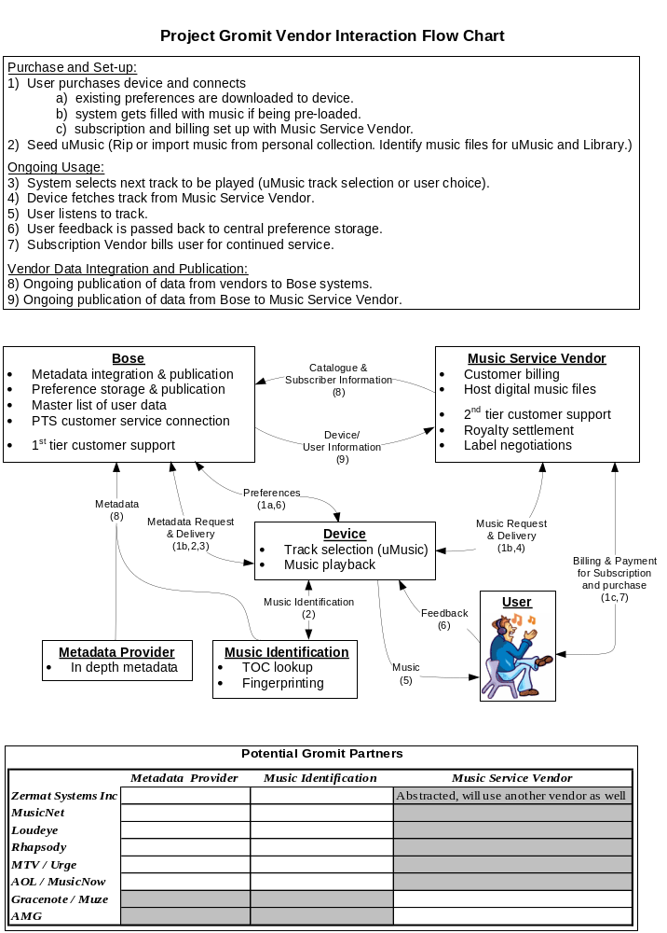
Gromit Development Overview

This development overview details the pieces that need to be built or bought to enable the Gromit vision. By design, these pieces will not match the building blocks in the flow chart on the previous page for the following reasons:
- The following list of development pieces goes into more detail than the flow chart
- The following list of development pieces does not include any services that don’t require explicit technology to be built or bought (i.e. hosting music files)

Buy before Launch
It is expected that the following services will be outsourced before Gromit launch:

Music Services
Possible vendors: Zermat Systems Inc., MusicNet, Loudeye, Rhapsody, Urge, MusicNow
- Billing and payment
- Customer support
- On-line access to music – subscription
- On-line access to music – purchase

Metadata & Music Identification Services
Possible vendors: Gracenote, AMG
- On-line CD TOC lookup service
- Fingerprint lookup service

Other Services
Possible vendors: TBD
- Physical album purchases

Device Specific Development (not part of Gromit)
Possible vendors: TBD
- Music management PC application - non-uMusic parts (Satori, Hannah)

Build for Launch
The following services are needed for Gromit Launch and are Bose specific development efforts. We will not be able to find off-the-shelf vendors to provide these systems. It is expected that we will outsource a large part of the development work.
Potential vendors: TBD
- Metadata integration and delivery
- Centralized user preferences
- Customer support systems

Device Specific Development
The following are needed for specific device implementations.
Potential vendors: TBD
- Music management PC application - uMusic parts (Hannah, Satori)
- Gromit embedded client (Satori, Cortez)

Ongoing Engineering
The following are to be developed after launch.
- PTS connection systems
- On-line database & firmware updates
- Wide Area Second Zone
- Device pre-loading services
- Server based uMusic (to support Soak and other thin clients)

Appendix B

Gromit Team Responsibilities:

For Program Launch:
  - APIs for communication to/from Gromit
  - Preference storage, synchronization/combination, and delivery systems
  - Design of user interface for web access to Music Subscription Service
  - Reference algorithms to enable Gromit services and uMusic (PC and otherwise)
  - Services related to a music subscription service, including but not limited to:
    - billing and user management services, monthly account processing, user access control, reporting customer status, information delivery to Bose
  - Metadata aggregation and publication services
  - Customer support services for music subscriptions and related outsourced vendor issues
  - On-line CD and digital file (mp3, wma, wav, etc.) Identification services for network enabled devices
  - Communication APIs and infrastructure to support PTS

After Launch:
  - Wide Area Second Zone enabling servers
  - Storage space for firmware images and embedded database
  - Server based uMusic (for Soak if needed)

Device Team Responsibilities:
  - All customer facing user interfaces except for the web interface to the Music Subscription Service
  - Music Management PC application - all functionality, including PC implementation of reference code of uMusic and Gromit communication APIs.
  - Embedded client versions of uMusic and uMusic Lite algorithms
  - Device processing of firmware and embedded database updates
  - Wide Area Second Zone user interface (not at Gromit launch)
  - Device side PTS functionality (not at Gromit launch)

IS Responsibilities:
  - Unified Customer Repository (UCR), definition of Interface(s) to the UCR, and any customer facing UI for the UCR.

PTS Responsibilities:
  - PTS applications and customer service interfaces

Business Recommendations:
  - Gromit should not be responsible for sales of initial Gromit enabled devices to users
  - Gromit should be responsible for
    - Cross-selling additional Gromit enabled devices to current users
    - Building and maintaining the Gromit brand
    - Free trial expenses
  - Gromit subscription fees and operational expenses should accrue to Gromit P&L

Appendix C
Terminology:
Application Programming Interface (API): The Music Services API will define a common set of functions (routines, protocols, and tools for building software applications) for the device developers.

DMCA Compliant Stream: Level of music subscription service that complies with the Digital Millennium Copyright Act of 1998 rules for webcasting.

Gromit Enabled: A Bose product that provides access to a Gromit provided Subscription Service and follows interface conventions defined by the Gromit specification.

Metadata: Textual information pertaining to music. E.g., Artist, Album, Track, Genre …

Music Fingerprinting: Fingerprinting is used to identify a song when all that is available is the digitized audio. Using a variety of mathematical transforms, audio is analyzed to create a unique “fingerprint”. This fingerprint is sent to a service where it is matched to a large collection of fingerprints of known songs. A fingerprinting service then returns the associated metadata for the song. Needed for integration of MP3 files.

Music Identification: Services needed to enable a device to identify a music file or CD. E.g., TOC (Gracenote) and audio fingerprinting.

Music Provider: A company that provides a music library and delivery interfaces to Gromit’s subscription service. E.g., MusicNet, Rhapsody.

Music Service Platform: Basic set of music services that are to be used by devices to access Gromit.

Music Services: All network enabled technology and services. E.g., music identification, centralized preference exchange, and subscription services.

Off-device uMusic Calculations: Creating a server that can perform the bulk of the uMusic calculations at a central location to enable thin clients.

Physical Product Purchase: To purchase music on a physical medium like a CD.

Preference Sharing: Using a centralized database for sharing user uMusic preferences between enabled devices.

Subscription Service: A service that enable user access to a large collection of music (1 Million+ tracks). E.g., direct access browsing tools, music file delivery, billing and user management systems.

TOC Lookup: TOC (or Table of Contents) lookup is used to identify a CD. Track length information is gathered from a CD and sent to a service which then returns metadata for the disc. Our current vendor for TOC lookup is Gracenote.

uMusic Lite: A “lite” version of uMusic that works only with a local music collection. A full uMusic experience can be enabled when connected to a server or thick client.

Wide Area Second Zone: The ability for a user to listen to or browse their personal collection of music from a location remote to the device storing the music, in particular via an Internet connected device.

The Digital Millennium Copyright Act reduces costs, but restricts the usage scenario; see Todd Krieger for more info.
Microsoft and MusicNet are likely partners; however, this has yet to be decided.

